Torment Card Preview: Chainer's Edict
Mike Turian
Thursday, January 3, 2002
One of my favorite Magic players, Elliot Fung, lives in California. During Tempest block the Pro Tour returned to the home of the legendary Queen Mary, Los Angeles, so of course Elliot was there. In my opinion, that entire Pro Tour was defined by one saying.
"Off the boat!"

Every time we crossed paths we would yip, "Off the boat!"
Now I am not a flavor text expert, but Diabolic Edict took the cake. Not only was it a versatile Magic card, it had some great flavor text. From a Pro Tour player's perspective, nothing can compare with "Off the boat!"
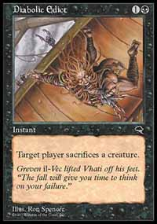
Luckily, while Diabolic Edict has for the most part been filed away in closets, Torment gives us the next printing of Diabolic.
Did they call it Diabolic Edict II? The Return of Diabolic Edict? Edict: The Revenge?
How about Chainer's Edict?
Yes, in fact that is what it is called.
Watch out, Diabolic Edict is back, and then back again.
Changing a card from an instant to sorcery will usually take the kick out of the spell. Besides the obvious lack of power Counterspell would have as a sorcery, cards like Giant Growth, and Muscle Burst would be miserable as sorceries.
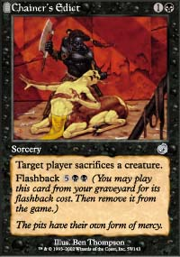
With creature removal however, cost is just as important a factor as is the speed in which it is cast. With Chainer's Edict the speed is not very important since it isn't targeted. Instead of waiting for your opponent to cast an enchantment, or play a fast effect just go ahead and Edict their creature right away.
Guess what? When you get to seven mana, you get to Edict all over again. The early game removal and mid-game flashback will insure that control decks keep their life totals high while gaining control and card advantage.
For Limited play, look for the blue-black archetype to gain strength with the power of Chainer's Edict. Wild Mongrel will be bound by the Edict.
Having problems with Iridescent Angel? Well, if you kill all of the Angel's little helpers, Chainer's Edict removes that untargetable beast.
Don't forget to combo Innocent Blood with the Edict for a solid one, two, seven punch. Perhaps some people will figure out how good the card is with bounce. Aether Burst those two, and kill that one. How about that for fun?
Creature removal is always a commodity in Limited, and Chainer's Edict is no exception. Even though your opponent gets to choose the creature, only cards like Chatter of the Squirrel and Squirrel Nest make this a problem. This brings me to a very important point: Squirrels rule!
Come to think of it, pretty much every squirrel-related card gives Chainer's Edict problems: Nut Collector, Deranged Hermit, Squirrel Wrangler, and Squirrel Nest all own the Edict. Ironically, Chainer's Edict helps keep Squirrel Mob under control.
Beyond cards that create creatures, the Chainer's Edict will be a valuable creature control card.
In the current Standard environment the two most popular and most powerful creatures, are Spiritmonger and Shadowmage Infiltrator. Chainer's Edict owns both, and if they ever draw another, Chainer's Edict owns that one too.
Card advantage has always been a big factor in Constructed play, and Chainer's Edict offers that in exchange for mana.
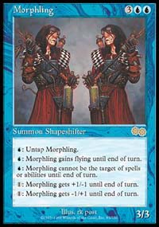
Don't forget "Superman". Morphling is vulnerable to this little spell as well, and anything that kills Morphling gets a big thumbs-up in my book. While Diabolic Edict is probably more reasonable in Extended since it also kills Ball Lightning, don't ever overlook more kryptonite for "Superman".
While this article began by discussing Diabolic Edict, it is very important to recognize that while similar in their effect the power of each is very different.
Diabolic Edict offered quick surprise removal in an environment that was defined by shadow creatures that raced ground and flying creatures.
Chainer's Edict is available in a format where Morbid Hunger is often flashed back for . So while seems like a high flashback cost, it is really very reasonable. This combined with the fact that, in Limited, creatures often don't start getting played until at least three lands are on the table, make Chainer's Edict an excellent choice for removal.
So before you go crying to your mother, father, brother, sister, or perhaps for those of you who need help, your dog, about how Wizards is just reprinting old cards, think about that for a second. Magic needs creature removal and Chainer's Edict is a welcome addition to the creature removal department.
If only Chainer's Edict would send Elliot off the boat.

